Who is Customer and what are his characteristics
A customer is an individual or organization that purchases goods or services from a business. Customers are essential to any business, as they drive revenue and growth.

Characteristics of a Customer:
- Needs & Wants: Customers seek products or services that fulfill their needs (essential requirements) or wants (desires).
- Decision-Making Process: They evaluate options based on price, quality, brand reputation, and personal preferences before making a purchase.
- Buying Power: Their ability to purchase depends on their financial status and willingness to spend.
- Loyalty & Retention: Some customers repeatedly buy from the same brand due to trust and satisfaction, while others may frequently switch brands.
- Behavior & Preferences: Customers have unique tastes, influenced by culture, trends, social proof, and personal experiences.
- Expectations: They expect quality products, excellent service, fast delivery, and sometimes personalized experiences.
- Feedback & Influence: Customers share reviews, recommend products, and influence others through word-of-mouth or online reviews.
- Emotional & Rational Triggers: Purchasing decisions can be driven by logic (cost-effectiveness, necessity) or emotions (desire, peer pressure, branding).
- Segmentation: Businesses categorize customers into groups such as demographics (age, gender, income), psychographics (lifestyle, values), and behavioral (purchase history, brand loyalty).
- Digital Engagement: In the modern world, many customers interact with brands online, through social media, websites, or e-commerce platforms.

Identify Your Customer Segments and Early Adopters
Identifying customer segments and early adopters is crucial for business success, especially for startups or new product launches. Here’s how you can do it:

Step 1: Define Your Market & Customer Segments
Customer segmentation involves dividing your target market into distinct groups based on shared characteristics. Common segmentation criteria include:
- Demographic Segmentation
  - Age, gender, income, education, occupation, family size
  - Example: A luxury brand targets high-income individuals
- Geographic Segmentation
  - Country, region, city, climate
  - Example: A winter clothing brand focuses on colder regions
- Psychographic Segmentation
  - Interests, values, lifestyle, personality
  - Example: A sustainable product appeals to eco-conscious consumers
- Behavioral Segmentation
  - Buying habits, product usage, brand loyalty, engagement level
  - Example: A subscription service targets customers who make frequent purchases
- Firmographic Segmentation (For B2B businesses)
  - Industry, company size, revenue, decision-making structure
  - Example: A SaaS product for enterprise-level companies

Step 2: Identify Early Adopters
Early adopters are the first customers to embrace your product. They are critical for validating your idea, providing feedback, and influencing the market.

Characteristics of Early Adopters
- Problem-Solvers – They actively seek solutions to specific pain points.
- Tech-Savvy or Trendsetters – They are open to trying new products before the masses.
- Risk-Tolerant – Willing to experiment with new, unproven solutions.
- Influencers – They share experiences through reviews, blogs, and word-of-mouth.
- Engaged & Vocal – They provide feedback and help shape product improvements.

How to Find Early Adopters
- Niche Communities & Forums – Engage in industry-specific online forums, Facebook groups, and LinkedIn discussions.
- Social Media & Influencers – Look for individuals discussing related topics or frustrations with existing solutions.
- Competitor Analysis – Identify users who are dissatisfied with competitor offerings.
- Crowdfunding Platforms – Platforms like Kickstarter and Indiegogo attract early adopters interested in innovation.
- Beta Testing & Pre-Launch Offers – Offer exclusive access, discounts, or trials to attract early users.
- Networking & Events – Attend industry meetups, conferences, and networking events to find passionate individuals.

Step 3: Validate & Refine Your Segments
Once you’ve identified customer segments and early adopters, validate your assumptions by:
- Conducting Surveys & Interviews – Gather direct feedback on pain points and expectations.
- Creating a Minimum Viable Product (MVP) – Launch a basic version and observe user behavior.
- Analyzing Data & Engagement Metrics – Use website analytics, email response rates, and social media interactions.
- Iterating Based on Feedback – Adapt your product and messaging to fit the most promising segments.
The difference between a consumer and a customer (decision maker),
The terms customer and consumer are often used interchangeably, but they have distinct meanings:

Key Differences:
Feature | Customer (Decision Maker) | Consumer
Definition | The person or entity that purchases a product or service. | The person or entity that uses or consumes the product or service.
Role | Makes the buying decision, may or may not use the product. | Uses the product, may or may not be the buyer.
Example | A parent buying a toy for their child. | The child playing with the toy.
Influence | Driven by price, brand, convenience, and budget. | Driven by experience, usability, and satisfaction.
B2B vs. B2C | Often seen in B2B (business-to-business) transactions. | More relevant in B2C (business-to-consumer) interactions.

Scenarios Where They Differ:
- Parent & Child → A parent buys a video game (customer), but the child plays it (consumer).
- Business & Employee → A company buys software (customer), but employees use it (consumers).
- Gift Purchases → Someone buys a perfume for a friend (customer), but the friend wears it (consumer).

Market Types, Segmentation and Targeting
Markets can be classified based on the type of buyers, the nature of transactions, and how businesses interact with their customers. Understanding market types helps in segmentation (dividing the market into groups) and targeting (choosing which groups to focus on).

1. Types of Markets

1.1 Consumer Markets (B2C – Business to Consumer)
- Target: Individual consumers who buy for personal use.
- Examples: Retail, e-commerce, food, electronics, fashion.
- Segmentation Basis:
  - Demographic: Age, gender, income, education (e.g., luxury brands target high-income consumers).
  - Geographic: Urban vs. rural, climate-based segmentation (e.g., winter jackets sold in colder regions).
  - Psychographic: Lifestyle, values, interests (e.g., organic food for health-conscious customers).
  - Behavioral: Purchase frequency, brand loyalty (e.g., frequent travelers targeted by airline loyalty programs).

1.2 Business Markets (B2B – Business to Business)
- Target: Companies, organizations, and institutions that buy products/services for operations or resale.
- Examples: SaaS software, industrial equipment, office supplies.
- Segmentation Basis:
  - Firmographics: Industry, company size, revenue (e.g., HR software targeting medium-sized firms).
  - Operational Needs: Business processes, pain points (e.g., logistics solutions for e-commerce brands).
  - Purchase Behavior: Bulk orders, contract-based vs. one-time purchases (e.g., corporate software licenses).

1.3 Industrial Markets
- Target: Businesses that require raw materials, components, or machinery for production.
- Examples: Steel suppliers, chemical manufacturers, electronic components.
- Segmentation Basis:
  - Industry Type: Automotive, construction, electronics.
  - Production Volume: Large-scale manufacturers vs. small businesses.

1.4 Financial Markets
- Target: Investors, traders, financial institutions.
- Examples: Stock markets, cryptocurrency exchanges, venture capital.
- Segmentation Basis:
  - Risk Appetite: Conservative vs. aggressive investors.
  - Investment Goals: Short-term trading vs. long-term wealth accumulation.

1.5 Government & Institutional Markets
- Target: Government agencies, NGOs, educational institutions, healthcare organizations.
- Examples: Defense contracts, public sector procurement.
- Segmentation Basis:
  - Public vs. Private Funding: Public institutions have strict procurement processes.
  - Project-Based Needs: Infrastructure development, education funding.

2. How to Segment & Target the Market

Step 1: Market Segmentation
Segmentation involves dividing the broader market into smaller, manageable groups based on similarities.
Key Segmentation Strategies:
- Demographic (Who they are) – Age, gender, income, occupation.
- Geographic (Where they are) – Country, city, climate.
- Psychographic (Why they buy) – Values, lifestyle, personality.
- Behavioral (How they buy) – Purchase habits, brand loyalty, spending patterns.

Step 2: Targeting the Right Market
After segmentation, decide which segments to focus on using these strategies:
- Undifferentiated (Mass Marketing)
  - Same product for all segments (e.g., Coca-Cola targets all soda drinkers).
- Differentiated (Segmented Marketing)
  - Different products for different segments (e.g., Toyota selling economy and luxury cars).
- Concentrated (Niche Marketing)
  - Focusing on a small, specialized segment (e.g., Rolex targeting luxury watch buyers).
- Micromarketing (Individual Marketing)
  - Personalization based on customer preferences (e.g., Custom Nike shoes).

Defining Customer Personas in Entrepreneurship
Customer personas are semi-fictional representations of your ideal customers, based on market research and real data. Entrepreneurs use personas to understand their target audience, improve marketing, and tailor products or services effectively.

1. What is a Customer Persona?
A customer persona (or buyer persona) includes details such as:
✅ Demographics (age, gender, income, location)
✅ Psychographics (lifestyle, values, motivations)
✅ Pain Points (challenges they face)
✅ Buying Behavior (where they shop, how they decide)
✅ Goals & Needs (what they hope to achieve)

2. Steps to Define Customer Personas

Step 1: Identify Your Target Market
- Who needs your product/service?
- What industry do they belong to?
- Are they individuals (B2C) or businesses (B2B)?

Step 2: Collect Data
Use:
- Surveys & Interviews (talk to real customers)
- Website Analytics (Google Analytics, social media insights)
- Market Research Reports
- Competitor Analysis

Step 3: Segment Your Audience
Group potential customers based on:
🔹 Demographics: Age, location, occupation, income
🔹 Psychographics: Values, interests, personality
🔹 Behavioral Traits: Buying habits, loyalty, engagement level

3. Example Customer Personas for Entrepreneurs

Persona 1: The Budget-Conscious Buyer (B2C)
💼 Name: Sarah, 28
📍 Location: Urban, mid-sized city
💰 Income: $40,000/year
🎯 Needs: Affordable, high-value products
😩 Pain Points: Limited budget, overwhelmed by options
🛍️ Buying Behavior: Prefers discounts, reads online reviews

Persona 2: The Growth-Oriented Startup Founder (B2B)
💼 Name: David, 35
📍 Location: Tech Hub (San Francisco, Berlin, etc.)
💰 Business Revenue: $500K/year
🎯 Needs: Scalable solutions, networking, mentorship
😩 Pain Points: Limited funding, struggling with marketing
🛍️ Buying Behavior: Invests in SaaS tools, attends startup events

4. Using Personas to Improve Business Strategy
✅ Product Development – Create products that solve real pain points.
✅ Marketing Strategy – Customize messaging and ads for each persona.
✅ Sales Approach – Target customers with tailored pitches.

Understanding Early Adopters & Customer Adoption Patterns
For entrepreneurs and businesses launching new products, understanding early adopters and the customer adoption process is crucial for success.

1. Who are Early Adopters?
Early adopters are the first users to embrace a new product or technology before it becomes mainstream.

Characteristics of Early Adopters:
✅ Open to Innovation – They seek new solutions to their problems.
✅ Risk-Tolerant – Willing to experiment with new, unproven products.
✅ Tech-Savvy & Trendsetters – Often active in niche communities and social media.
✅ Influencers – They share reviews, provide feedback, and influence others.
✅ Problem-Solvers – They buy based on how well a product solves a specific pain point.

Where to Find Early Adopters?
📌 Online Communities & Forums – Reddit, Discord, Facebook Groups.
📌 Social Media & Influencers – Twitter, LinkedIn, YouTube.
📌 Beta Testing Platforms – Product Hunt, IndieHackers, Kickstarter.
📌 Industry Events & Conferences – Networking with early adopters in niche markets.

2. Customer Adoption Patterns (Technology Adoption Lifecycle)
The Technology Adoption Lifecycle (Everett Rogers’ Diffusion of Innovations) explains how different customer segments adopt new products at different rates.

The 5 Stages of Customer Adoption
Customer Group | % of Market | Characteristics
1. Innovators | 2.5% | First to try, risk-takers, experimenters.
2. Early Adopters | 13.5% | Visionary, influential, willing to invest early.
3. Early Majority | 34% | Wait for proof before adopting.
4. Late Majority | 34% | Skeptical, adopt only when necessary.
5. Laggards | 16% | Resistant to change, prefer traditional solutions.
🔹 Key Insight: Early adopters influence the early majority, making them crucial for market growth.

3. How to Drive Early Adoption?

✅ Step 1: Identify a Niche Problem
🔍 Early adopters seek products that solve specific pain points better than existing solutions.

✅ Step 2: Build a Minimum Viable Product (MVP)
🚀 Offer a basic but functional version of your product for testing.

✅ Step 3: Create an Exclusive Experience
🎟 Beta Access, Special Offers, or VIP Memberships – This attracts early adopters who want to be first.

✅ Step 4: Leverage Word-of-Mouth & Social Proof
📢 Encourage reviews, testimonials, and referrals from early adopters to attract the early majority.

✅ Step 5: Continuously Gather Feedback & Iterate
🔄 Use feedback from early users to improve the product before scaling to a wider audience.

4. The Chasm: The Challenge of Scaling Beyond Early Adopters
📉 Many startups fail between the Early Adopters and the Early Majority (known as "The Chasm", Geoffrey Moore).

How to Cross the Chasm?
✅ Simplify the product – Reduce complexity for mainstream users.
✅ Target a specific niche within the early majority – Don’t generalize too soon.
✅ Use case studies & testimonials – Build trust with risk-averse buyers.
✅ Improve onboarding & customer support – Make adoption easier.

Final Thoughts
Early adopters are key to product success, but scaling requires bridging the gap between innovators and the mass market.

Identifying Innovators & Early Adopters for Your Startup

Step 1: Define Your Startup's Core Value Proposition
Before identifying who your innovators and early adopters are, clarify:
- What problem does your startup solve?
- How is it better or different than existing solutions?
- Who experiences this pain point the most?

Step 2: Identify Your Innovators (First 2.5% of Users)
Innovators are the first group to adopt new technology or products. They are:
✅ Risk-Takers & Experimenters – Love testing new things.
✅ Tech-Savvy & Curious – Follow trends and emerging technologies.
✅ Invested in the Industry – Often entrepreneurs, developers, or hobbyists.
✅ Community-Driven – Engage in online forums, beta-testing groups, and hackathons.
🔍 Where to Find Them?
📌 Tech & Startup Forums – IndieHackers, Hacker News, GitHub, Reddit.
📌 Beta Testing Platforms – Product Hunt, Betalist, Kickstarter.
📌 Early Tech Conferences – CES, Web Summit, TechCrunch Disrupt.
📌 Online Communities & Discord Groups – Look for niche problem solvers.
💡 Example (AI Startup): If you launch an AI-powered writing tool, innovators will be AI researchers, developers, and tech enthusiasts who experiment with AI-based solutions before the mainstream.

Step 3: Identify Your Early Adopters (First 13.5% of Users)
Early adopters are slightly more cautious than innovators but still:
✅ Actively Seek New Solutions – Frustrated with existing options.
✅ Trendsetters & Influencers – Shape opinions in their industries.
✅ Problem-Solvers – Willing to pay for a solution before mass adoption.
✅ Opinion Leaders – Have strong networks and communities.
🔍 Where to Find Them?
📌 Industry-Specific LinkedIn & Twitter Groups – Look for discussions on pain points.
📌 Niche YouTube Channels & Podcasts – Early adopters often create or follow industry content.
📌 Newsletter Subscribers – Look for email lists discussing new tech or market trends.
📌 Webinars & Thought Leadership Events – They attend and engage in problem-solving.
💡 Example (Fintech Startup): If you launch a new budgeting app, early adopters could be personal finance influencers, bloggers, or young professionals who struggle with money management and are excited about new tech-based solutions.

Step 4: Build a Go-To-Market Strategy for Innovators & Early Adopters

🚀 For Innovators:
- Offer exclusive beta testing access to let them experiment.
- Engage in developer communities if it’s a tech-driven product.
- Leverage Kickstarter or Product Hunt to gain visibility.

🔥 For Early Adopters:
- Create compelling use cases & success stories to showcase value.
- Offer early discounts or VIP access to create urgency.
- Use thought leadership marketing (blogs, podcasts, case studies).

Final Thought
Innovators help you refine your product, while early adopters help you build credibility and demand. Identifying them early will accelerate your startup’s growth and adoption.

Crafting Your Value Proposition
A value proposition is a clear statement that explains:
✅ What your product/service does
✅ Who it’s for
✅ Why it’s better than the alternatives
A strong value proposition helps attract early adopters and differentiates your startup from competitors.

1. Formula for a Strong Value Proposition
🔹 [Product/Service] helps [Target Audience] solve [Key Problem] by [Unique Solution], unlike [Competitor or Alternative] which [Limitation of Competitor].
OR
🔹 "We help [Target Customer] achieve [Desired Outcome] by providing [Unique Benefit], without [Pain Point or Frustration]."

2. Steps to Craft Your Value Proposition

Step 1: Identify Your Target Audience 🎯
- Who is your ideal customer? (e.g., startups, freelancers, enterprises)
- What is their biggest pain point?
💡 Example: Young professionals struggling to manage their personal finances.

Step 2: Define the Key Problem ❌
- What frustrations or inefficiencies do they face?
- Why haven’t existing solutions worked for them?
💡 Example: "People find budgeting apps too complicated and time-consuming."

Step 3: Highlight Your Unique Solution 🔥
- How does your product solve the problem better than alternatives?
- What is your main competitive advantage?
💡 Example: "Our AI-powered budgeting app automates expense tracking and financial planning in seconds."

Step 4: Differentiate from Competitors 🏆
- Why should customers choose you over other solutions?
- What makes your approach unique or better?
💡 Example: Unlike traditional budgeting apps, ours requires zero manual input and learns spending habits automatically.

3. Value Proposition Examples

✅ Example 1: Fintech Startup (Personal Finance App)
“We help young professionals achieve financial freedom by automating budgeting and savings, without the hassle of spreadsheets or manual tracking.”

✅ Example 2: AI-Powered Writing Assistant
“Our AI-powered writing tool helps content creators generate high-quality articles 10x faster, without writer’s block or endless revisions.”

✅ Example 3: SaaS for Small Businesses
“We provide small businesses with an all-in-one invoicing and expense management system, so they can focus on growth instead of accounting.”

4. Test & Refine Your Value Proposition
- Is it clear and simple? (Avoid jargon!)
- Does it address a real pain point?
- Can someone read it and immediately understand what you offer?

Creative Solutions for Identified Problems
Now that we've outlined the key challenges faced by early adopters and target customers, let's develop innovative solutions that make your startup stand out.

1. Problem: Budgeting Apps Are Too Complicated & Time-Consuming
💡 Solution: "Invisible Budgeting" App
- AI auto-categorizes expenses without manual input.
- Smart voice assistant tracks spending via voice commands.
- "Set it & forget it" approach: AI automatically adjusts savings based on spending habits.
- Gamification: Users earn rewards for staying within budget.
🚀 Unique Angle: Zero-effort personal finance management.

2. Problem: Writers Struggle With Writer’s Block & Content Creation Takes Too Long
💡 Solution: AI-Powered "Co-Writer"
- AI suggests real-time content ideas based on trending topics.
- Voice-to-text feature: Dictate ideas, and AI refines them into polished content.
- Smart collaboration: AI adapts to your writing style and provides structure.
- Auto-research: AI gathers relevant sources and citations automatically.
🚀 Unique Angle: Turn ideas into full articles in minutes.

3. Problem: Small Business Owners Spend Too Much Time on Accounting
💡 Solution: Smart Invoicing & Expense Management App
- Auto-generates invoices and sends reminders without manual input.
- AI detects tax deductions and automates tax filing.
- WhatsApp Integration: Send invoices and expense receipts directly via chat.
- Predictive cash flow insights: AI forecasts financial health & alerts risks.
🚀 Unique Angle: Automated accounting with zero learning curve.

4. Problem: Finding Early Adopters for a New Startup Is Difficult
💡 Solution: Exclusive “Beta Club” for Early Adopters
- Members get lifetime discounts & VIP access to new features.
- Community-driven testing: Users vote on upcoming product changes.
- Personalized onboarding: 1-on-1 support and co-creation sessions.
- Partner with micro-influencers for referral-based incentives.
🚀 Unique Angle: Turn early adopters into engaged product ambassadors.

5. Problem: Traditional Networking Events Are Boring & Ineffective
💡 Solution: AI-Matched Networking App
- AI matches users based on interests & business goals.
- Icebreaker challenges: Gamify conversations with fun prompts.
- Smart follow-ups: AI suggests when & how to reconnect after events.
- VR/Metaverse networking spaces for global remote connections.
🚀 Unique Angle: Networking made fun, strategic, and AI-powered.

Deep Dive into Gains, Pains, and "Jobs-To-Be-Done" (Using the Value Proposition Canvas - VPC)
The Value Proposition Canvas (VPC) is a framework that helps startups align their product or service with customer needs by focusing on three key areas:
✅ Customer Jobs (What the customer is trying to do)
✅ Pains (Challenges and frustrations they face)
✅ Gains (Desired benefits and positive outcomes)

1. Understanding Customer Segments
Before using the VPC, define who your customer is. Ask:
- What problem are they trying to solve?
- What motivates their decision-making?
- What frustrates them with current solutions?
🔹 Example: Let’s analyze an AI-powered budgeting app for young professionals.

2. Value Proposition Canvas Breakdown
The VPC consists of two sides:

🔵 Customer Profile (Understanding the User)
1️⃣ Jobs-To-Be-Done (JTBD):
- Functional: Manage personal finances easily
- Emotional: Reduce stress about money
- Social: Feel responsible & financially independent
2️⃣ Pains (Customer Frustrations):
❌ Manual budgeting is time-consuming.
❌ Hard to track expenses across different bank accounts.
❌ Too many complex finance tools with overwhelming features.
❌ Fear of unexpected financial crises.
3️⃣ Gains (Desired Benefits):
✅ Automatically track expenses with zero manual input.
✅ See real-time financial health insights in one dashboard.
✅ Get smart alerts for overspending & upcoming bills.
✅ Build better saving habits without strict restrictions.

🟢 Value Proposition (How Your Product Delivers Value)
1️⃣ Pain Relievers (How the product removes pains):
🔹 AI auto-categorizes transactions without manual effort.
🔹 Smart notifications prevent overspending & missed bills.
🔹 Aggregates multiple bank accounts into one clean interface.
🔹 Generates easy-to-understand financial health reports.
2️⃣ Gain Creators (How the product enhances life):
🔹 Gamifies savings with milestone rewards & badges.
🔹 Predicts future financial trends based on habits.
🔹 Integrates with WhatsApp for on-the-go finance updates.
🔹 Offers personalized financial tips to help users grow wealth.

3. Visual Representation of the VPC
Customer Profile | Value Proposition
Jobs-To-Be-Done (JTBD): Track spending, budget easily, save more. | Products & Services: AI-powered budgeting app
Pains: Manual tracking is annoying, complex tools overwhelm, fear of financial instability. | Pain Relievers: Auto-budgeting, real-time tracking, easy UI, smart alerts.
Gains: Stress-free money management, effortless savings, and confidence in financial future. | Gain Creators: Personalized advice, gamified savings, financial forecasting.

4. Applying This to Your Startup
Now, let's apply the Value Proposition Canvas to your business idea:
- Who is your target customer?
- What "jobs" are they trying to get done?
- What pains do they experience?
- What gains would make their life better?

Identifying the Unique Value Proposition (UVP) Using the Value Proposition Canvas (VPC)
Your Unique Value Proposition (UVP) is the core reason why customers should choose your solution over competitors. It combines your key Pain Relievers, Gain Creators, and Jobs-To-Be-Done into a compelling, easy-to-understand statement.

Step 1: Define the Customer's Perspective (Customer Profile)
For an AI-powered budgeting app for young professionals, we identified the following:
🔹 Jobs-To-Be-Done (JTBD):
- Manage finances effortlessly
- Save money automatically
- Reduce financial stress
🔹 Pains (Customer Frustrations):
- Budgeting takes too much effort
- Hard to track spending across multiple accounts
- Fear of financial instability
🔹 Gains (Desired Benefits):
- A simple, automated financial system
- Smart savings without manual input
- Clear financial insights to feel in control

Step 2: Define Your Value Proposition (Solution Perspective)
🟢 Pain Relievers (How We Solve the Customer’s Pains):
✅ AI-powered automatic expense tracking—no manual input required
✅ Smart alerts prevent overspending & missed bills
✅ Aggregates all bank accounts into one clean dashboard
🟢 Gain Creators (How We Enhance the Customer’s Experience):
✅ Gamified savings goals—make saving fun & engaging
✅ Personalized financial tips to help users build wealth
✅ Predictive analytics to forecast future spending trends

Step 3: Craft the Unique Value Proposition (UVP)
💡 UVP Formula:
"We help [Target Audience] solve [Key Pain] by providing [Unique Solution], so they can achieve [Key Gain] without [Pain Point]."
🚀 UVP for AI Budgeting App:
“We help young professionals take control of their finances effortlessly with AI-powered automatic budgeting, so they can save more and stress less—without spending hours tracking expenses.”

Finalizing Your UVP
A strong UVP should be:
✔ Clear & simple – No jargon, easy to understand.
✔ Benefit-driven – Focused on what the customer gains.
✔ Differentiated – Highlights what makes it unique.
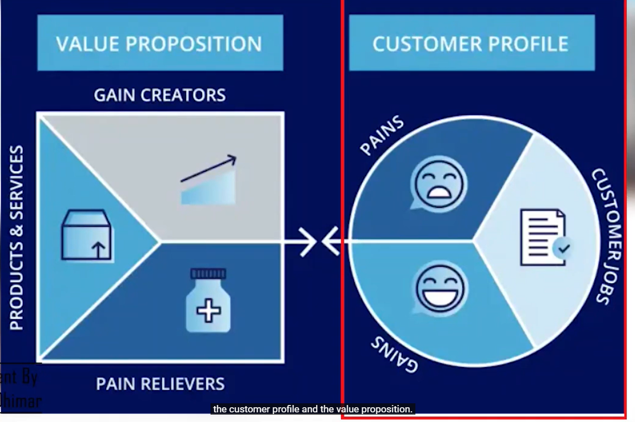

Outcome-Driven Innovation (ODI): A Customer-Centric Approach

What is Outcome-Driven Innovation (ODI)?
Outcome-Driven Innovation (ODI) is a customer-centric approach to product development that shifts the focus from features to desired customer outcomes. Instead of asking "What features should we add?", ODI asks "What outcomes do customers want to achieve?"
By understanding the functional, emotional, and social jobs customers need to get done, businesses can create highly targeted, innovative solutions that meet real needs.

1. The Core Principles of ODI
🔹 Customers "hire" products to get a "job" done.
🔹 Customers don’t want features—they want better outcomes.
🔹 Innovation should focus on improving efficiency, reducing risk, and increasing satisfaction.
🔹 Success = Delivering the best solution for a specific job-to-be-done (JTBD).

2. Applying ODI: From Customer Jobs to Innovation

Step 1: Identify the "Job-To-Be-Done" (JTBD)
Ask:
✔ What is the main problem the customer is trying to solve?
✔ What is the end goal they want to achieve?
✔ What are the frustrations with current solutions?
💡 Example: Budgeting App
🔹 JTBD: "I want to track and manage my finances effortlessly."

Step 2: Define the Desired Outcomes
Customers want products that help them:
✅ Save time (Easier, faster process)
✅ Reduce risk (Fewer mistakes, more accuracy)
✅ Increase success (Achieve a better result)
✅ Feel in control (More confidence in decisions)
💡 For a Budgeting App:
🔹 Bad Outcome: "I have to manually enter every expense."
🔹 Good Outcome: "My expenses are categorized automatically with no effort."

Step 3: Identify Unmet Needs & Innovation Opportunities
By analyzing what outcomes customers struggle to achieve, businesses can create targeted innovations.
Unmet Customer Need | Innovation Opportunity
“It’s hard to track all my expenses in one place.” | Unified financial dashboard with all accounts synced.
“I don’t know where my money goes each month.” | AI-generated spending insights with personalized reports.
“Budgeting feels overwhelming and restrictive.” | Gamified savings goals to make budgeting fun and engaging.

3. ODI in Action: Real-World Examples

🚀 Netflix (Outcome: Effortless Entertainment)
🔹 JTBD: “I want to watch my favourite shows without interruptions.”
🔹 Old Pain: Renting DVDs, waiting for availability.
🔹 Innovative Solution: Streaming on-demand, personalized recommendations.

🚀 Uber (Outcome: Convenient Transportation)
🔹 JTBD: “I want a reliable ride without hassle.”
🔹 Old Pain: Calling taxis, unpredictable pricing, long wait times.
🔹 Innovative Solution: On-demand ride-hailing, transparent pricing, driver tracking.

4. Creating an ODI-Driven Innovation Strategy for Your Business

✅ Step 1: Survey Customers on Their Desired Outcomes
- What are their biggest frustrations?
- What would an ideal solution look like?

✅ Step 2: Prioritize the Most Critical Outcomes
- Which unmet needs create the most pain?
- Where can your solution differentiate from competitors?

✅ Step 3: Innovate Based on the Outcomes (Not Features)
- Instead of: "Let’s add a new dashboard."
- Ask: "How can we make budgeting effortless?"

Class Presentation: Communicating the Value Proposition - 1 min Customer Pitch


Example: Cultivate scientific learning experience for Students
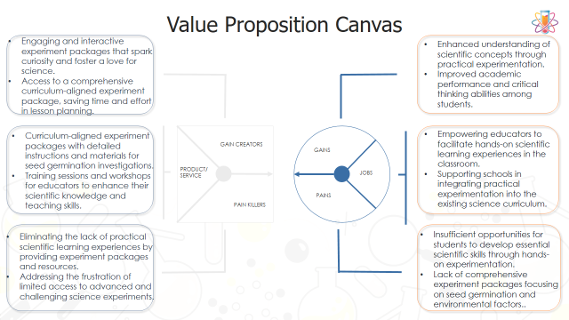

BUSINESS MODEL: Get Started with Lean Canvas
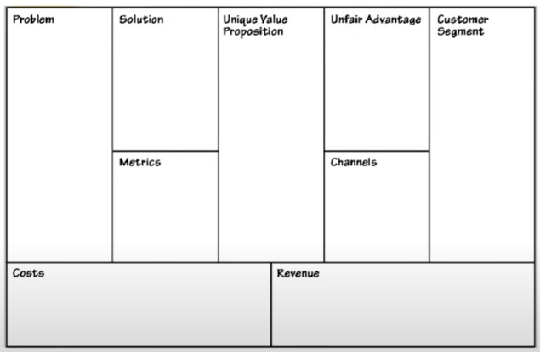

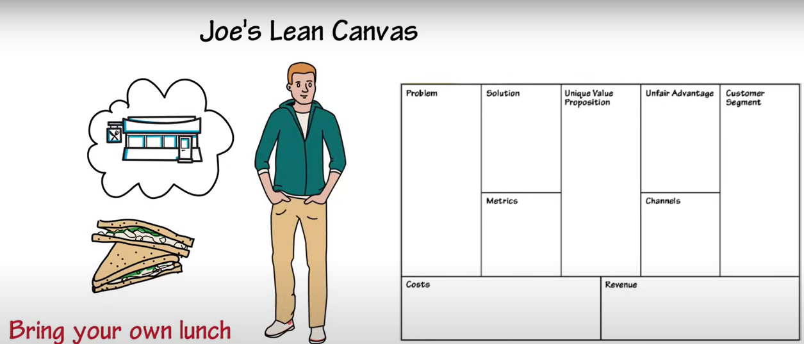

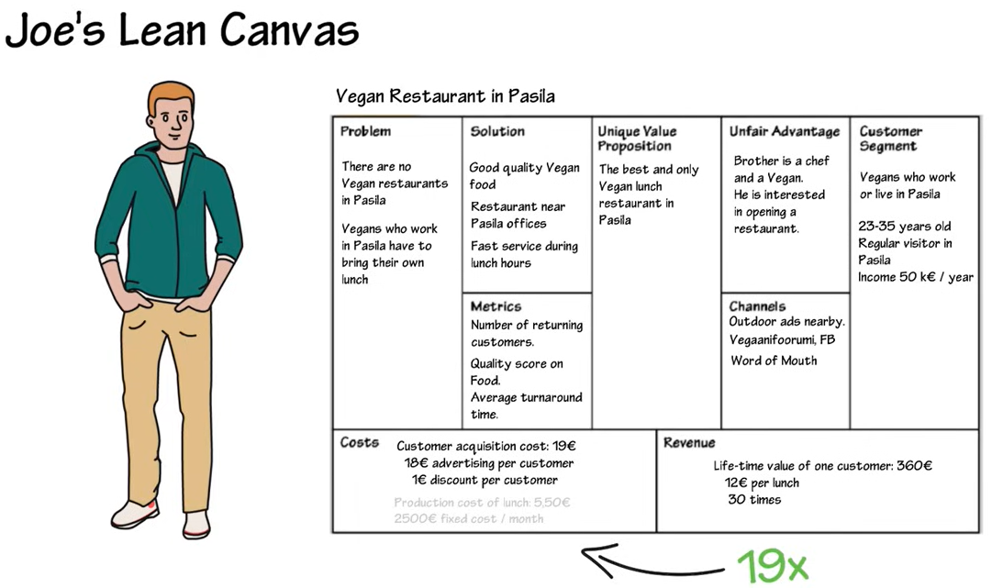

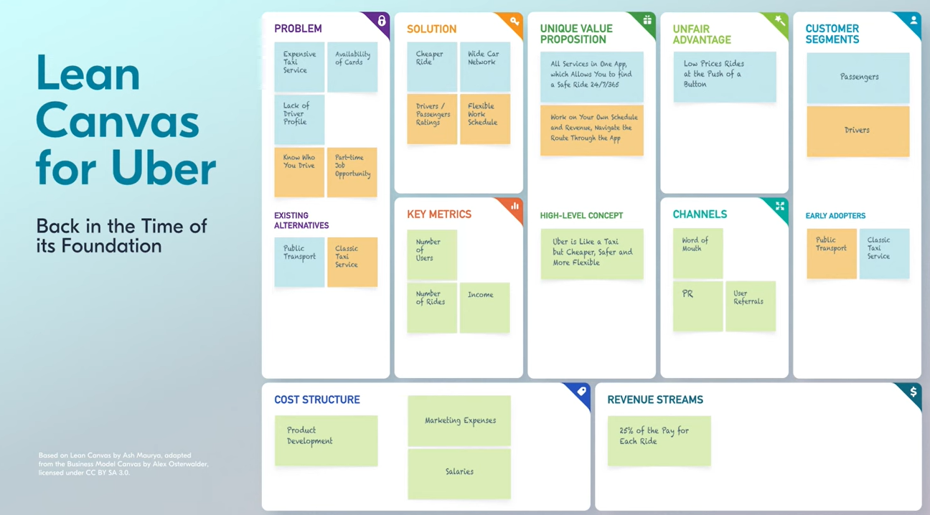

Example: Cultivate scientific learning experience for Students
